**INFO 6205**

**Program Structures & Algorithms**

**Fall 2020**

**Final Project**

**Introduction about the topic**

COVID-19 is spreading worldwide and causing great harm to people. Among the population, mortality rates are high for the elderly and children. Although young people are relatively safer, infection can have indelible consequences. Quarantine seems to be the best way to avoid the spread of virus. Some countries deal with it well, compared with the United States, which seems to be doing poorly because of the lack of awareness of the effects of the virus.

**Aim of the project**

Our aim is to simulate the spread of a COVID-19 and SARS, compare the two virus and draw conclusion form the observations. This project simulates the spread of viruses by comparing different K and R factors of viruses, such as covid19 and SARS viruses, population density, the use rate of masks and the maximum number of people isolated in hospitals. We can simulate the number of infected people in the area after infection, as well as in the area of infection. The infectivity of the virus is determined by the number of days.

**Complete project details**

We take the follow points into account:

* ***The R and k factors of the disease:*** The meaning of R factor is clear which is one person could infected three people on average. Whereas the k (from 0 to 1) factor seems to stand for stability of infection, which is hard understand. We only know that the small the k, he smaller the proportion of people who infect others, but they would infect more people than average. Therefore, we set the k to be 0.3 (very unstable) and the number of max infections of single person to be R/k.
* ***The population density:*** We use 1 as the safe distance and 0.9d as the value that affects the risk of infection given d is distance between two people.
* ***The usage and effectiveness of masks:*** In fact, most people reluctant to wear masks for a long time during the outbreak. Thus, we set the rate to ware mask to be 0.05. Considering the good defensive effect of the mask, we decrease the risk by 90 percent with mask.
* ***The prevalence of testing:*** Since usually the prevalence of testing is not high, plus not everyone is willing to be tested, the rate of test is set to 0.6, resulting the testing infections lower than True number.
* **Quarantining:** The hospital acts as a quarantine and can accommodate up to 200 patients. The patients in hospital will not able to infect others.

**Implementation - charts, algorithm**

**Output**

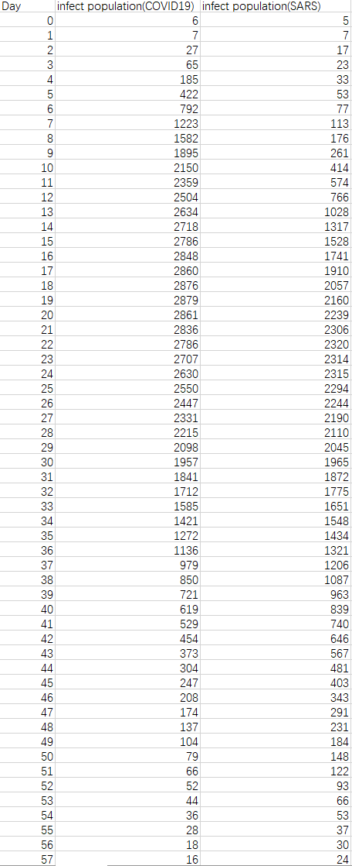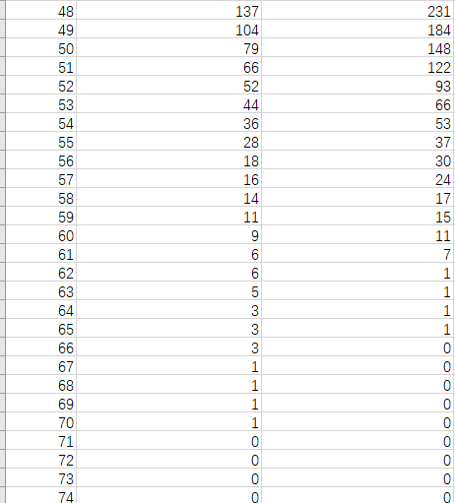

**SARS**

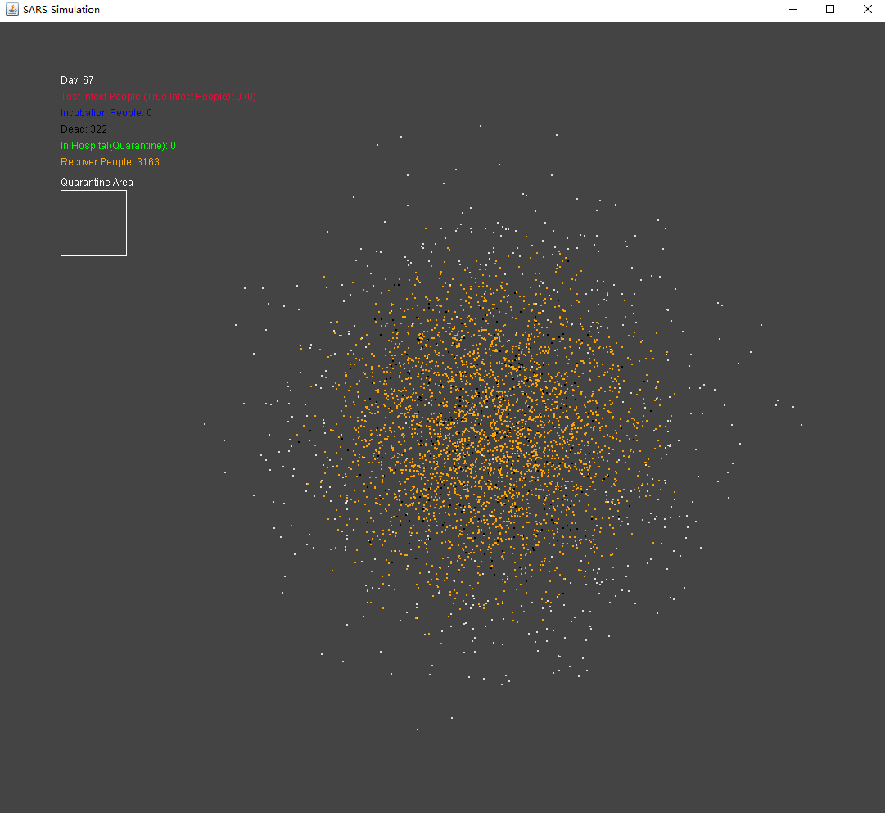

**COVID19**

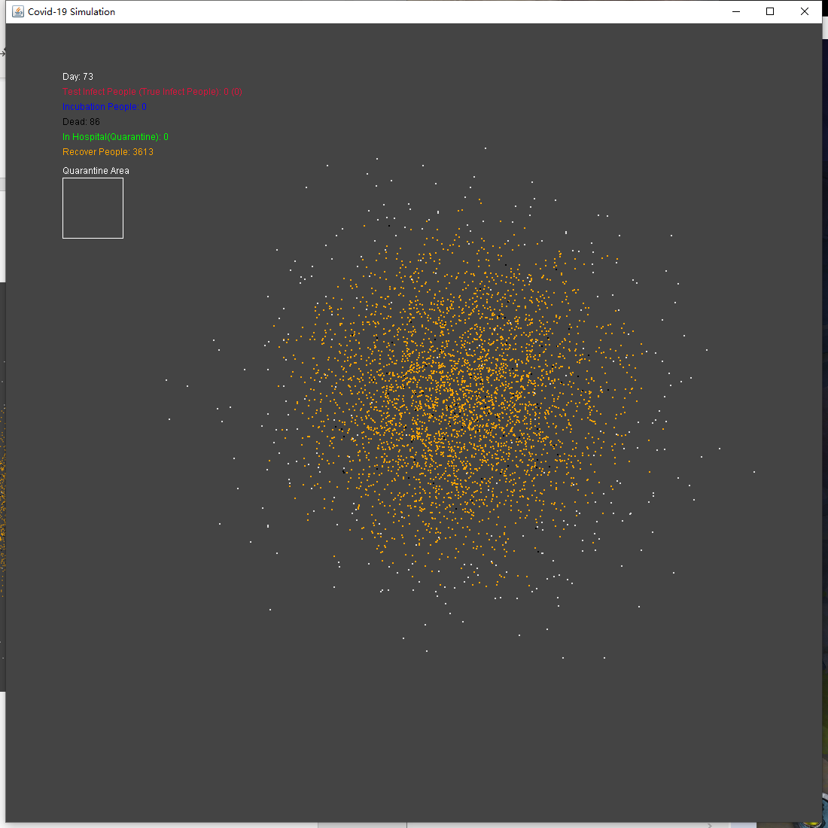

**Mathematical analysis/evidence**

Take the COVID-19 as an example, the R of COVID-19 is 3, 1 person should be able to infect 3 people when k equals to 1. In this project, we set k to be 0.3, which means 1 person has a 30 percent chance of being able to infect others and could infect 10 people. We also assume that the infection rate, mask defense, death rate, capacity of the quarantine are constant, infection number, incubation number, death number, recover number are variables.

We simulate the distribution of people in a city and use the Gaussian distribution to give the initial and moving positions of people. We could see that for COVID-19, the number of infection grows by y = 31.565x2 - 63.316x + 5.6905; for SARS, the number of infection grows by y = 12.279x2 - 93.974x + 161.66. COVID-19 and SARS peaked at about 2320 and 2879, respectively. In the recovery phase, COVID-19 is reduced by y = 2.0573x2 - 166.75x + 2948.7, and SARS is reduced by y = 0.3662x2 - 108.57x + 2449.3.

At last, we conclude from the death number and recover number that the death rate of COVID-19 is dead/(dead+recovery)=2.32%, the death rate of SARS is 9.24%.

To simulate infection, we use two “for” loop so that the complexity should be O(n2).

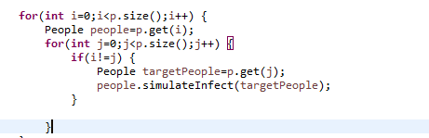

**Conclusion**

Through the experiment of simulating the spread of virus, we can simulate the spreading process of virus. By comparing the virus with different K / R factors, population distance density and mask usage rate with the correct use of defense rate and isolation effectiveness, we can conclude that people need to keep distance and wear masks. If you're infected, you need to go to the quarantine area. The complexity of the algorithm to simulate the virus propagation process is n2. For the improvement of the algorithm, we can use quick union to make infected and uninfected into two groups, so as to reduce the number of traversing human infection.

**Unit Test**

See the “Test for Final Project.pdf”